Balancing the Three treasures
There are considered to be three main energy centres called “Dantien” that are used in Qigong practice. These are said to relate to the “three treasures”, Jing, Qi and Shen.
Balancing the three treasures is a meditation sequence using three simple postures, to clear and rebalance the major energy centres, or Dan Tien. You should aim to gradually increase the strength and quality of feedback from each posture.
You are looking for a sensation of connection, which you may feel in a number of ways, vibration, warmth, coolness, or whatever, it’s a personal thing. It is even possible that you will experience connection as sound, images, or emotions, the form of experiencing connection is unimportant.
What is important is that you develop your ability to ‘tune in’ to the connection, first between your hands, then between your hands and the energy centres

It is normal to experience physical sensations such as pins and needles or a feeling of something crawling on the skin; scar tissue may also be sensitive. However pain is an indication that something is not right so stop immediately using a slow movement and seek advice from your teacher.

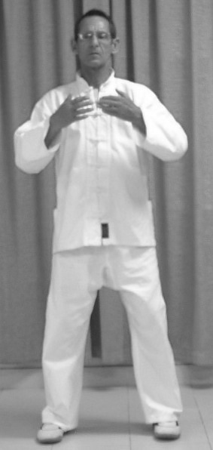
Things to remember
Use a calm but positive visualisation of energy flow at each energy centre.

Using diaphragmatic breathing through out, with every breath you should feel the connection of energy between the hands.

Movements are smooth, postures without sharp angles or locked joints.

The hands must have ‘life’, not limp, not rigid or over extended, but with the energy extended to the fingertips.

When descending, lower the arms at each stage on an exhalation, pause at each stage for as long as you feel able, two minutes is about right for novices.

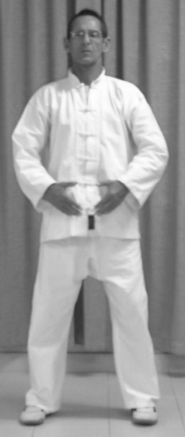
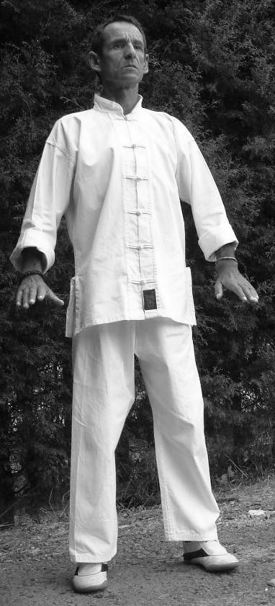
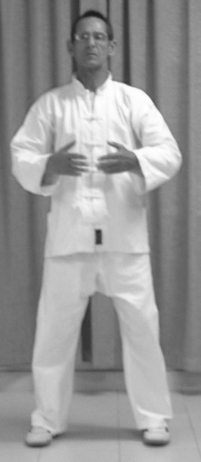
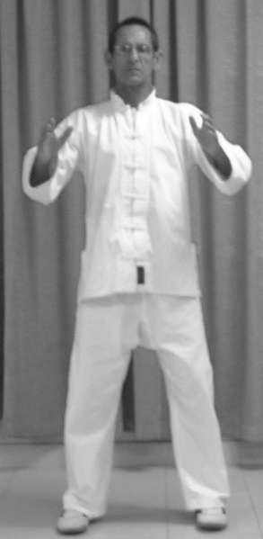
Begin from the Wu Chi posture (P1)

1. Inhale as you circle the arms out from the body until the palms face the lower Dantien (P2) then inhale and raise the hands to around the abdomen with the thumbs inline with the navel. The hands should not touch each other. (P3) Exhale. Stay in this posture inhaling and exhaling until a connection is felt between the hands. (P3,P4) You can rub the hands together to enhance this process.

P1 P2 P3 P4(inhale) P5 (exhale)

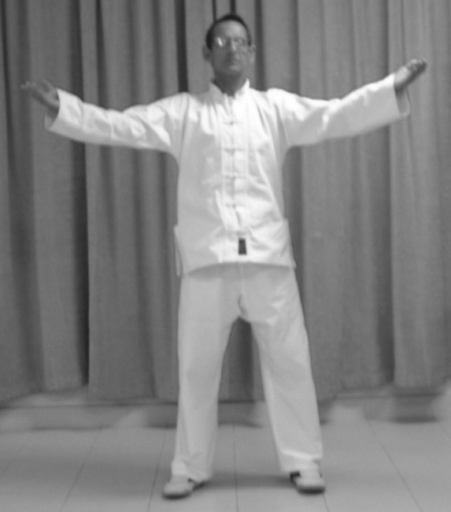
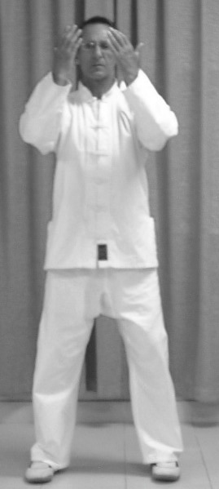
2. From this position, Inhale as you raise the arms until the hands are level with the forehead, with the palms facing in, towards the body. (P6) hold the posture, and connection between the hands and the head, breathing gently until you feel the brow energy centre clear. The connection can be close (P6) or further away (P7).

P6 P7

3. In time with an exhalation, gently lower the hands until they are level with the heart.
Palms facing the heart (P8).
Again hold the posture breathing gently until the energy centre in the chest feels clear and balanced.
As before the posture can be adjusted to maximise the awareness, or ‘tuning’.

P8➔

4. In time with an exhalation, gently lower the hands until they are level with the lower Dan Tien
Palms facing inward. (P9) Again hold the posture breathing gently Visualise energy being stored in the Dan Tien with every inhalation, and negative energy being released with every exhalation.

Move into and out of each posture smoothly and slowly. The arms should be curved throughout the movements and postures, as if encircling a ball. To finish the sequence, lower the hands slowly on an exhalation . Use a calm movement such as ‘Wiping the barrel’ (hip circles) or ‘Cloud hands’ to return to alertness.

